Cognizant - DN 4.0 Deep Skilling Java FSE

Week 06 - React

Superset ID: 6383725

Name: G Ashritha

**Exercise 9: ES6**

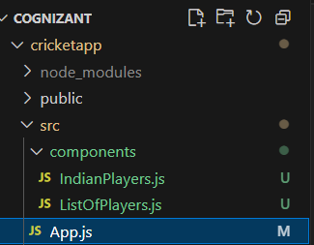

//App.js

import React from 'react';

import ListOfPlayers from './components/ListOfPlayers';

import IndianPlayers from './components/IndianPlayers';

function App() {

  return (

    <div className="App" style={{ padding: '20px', fontFamily: 'Arial' }}>

      <ListOfPlayers />

      <hr />

      <IndianPlayers />

    </div>

  );}

export default App;

//IndianPlayers.js

import React from 'react';

const IndianPlayers = () => {

  const team = ["Sachin", "Dhoni", "Virat", "Rohit", "Yuvraj", "Raina"];

  const [first, second, third, fourth, fifth, sixth] = team;

  const T20players = [

    "Mr. First Player", "Mr. Second Player", "Mr. Third Player"

  ];

  const RanjiPlayers = [

    "Mr. Fourth Player", "Mr. Fifth Player", "Mr. Sixth Player"

  ];

  const mergedPlayers = [...T20players, ...RanjiPlayers];

  return (

    <div>

      <h2>Odd Players</h2>

      <ul>

        <li>First: {first}</li>

        <li>Third: {third}</li>

        <li>Fifth: {fifth}</li>

      </ul>

      <h2>Even Players</h2>

      <ul>

        <li>Second: {second}</li>

        <li>Fourth: {fourth}</li>

        <li>Sixth: {sixth}</li>

      </ul>

      <h2>List of Indian Players Merged:</h2>

      <ul>

        {mergedPlayers.map((player, index) => (

          <li key={index}>{player}</li>

        ))}

      </ul>

    </div>

  );

};

export default IndianPlayers;

//ListOfPlayers.js

import React from 'react';

const ListOfPlayers = () => {

  const players = [

    { name: "Jack", score: 50 },

    { name: "Michael", score: 70 },

    { name: "John", score: 40 },

    { name: "Ann", score: 61 },

    { name: "Elisabeth", score: 61 },

    { name: "Sachin", score: 95 },

    { name: "Dhoni", score: 100 },

    { name: "Virat", score: 84 },

    { name: "Jadeja", score: 64 },

    { name: "Raina", score: 75 },

    { name: "Rohit", score: 80 }

  ];

  const lowScorers = players.filter(player => player.score < 70);

  return (

    <div>

      <h1>List of Players</h1>

      <ul>

        {players.map((player, index) => (

          <li key={index}>Mr. {player.name} {player.score}</li>

        ))}

      </ul>

      <h2>List of Players having Scores Less than 70</h2>

      <ul>

        {lowScorers.map((player, index) => (

          <li key={index}>Mr. {player.name} {player.score}</li>

        ))}

      </ul>

    </div>

  );

};

export default ListOfPlayers;

**Output:**

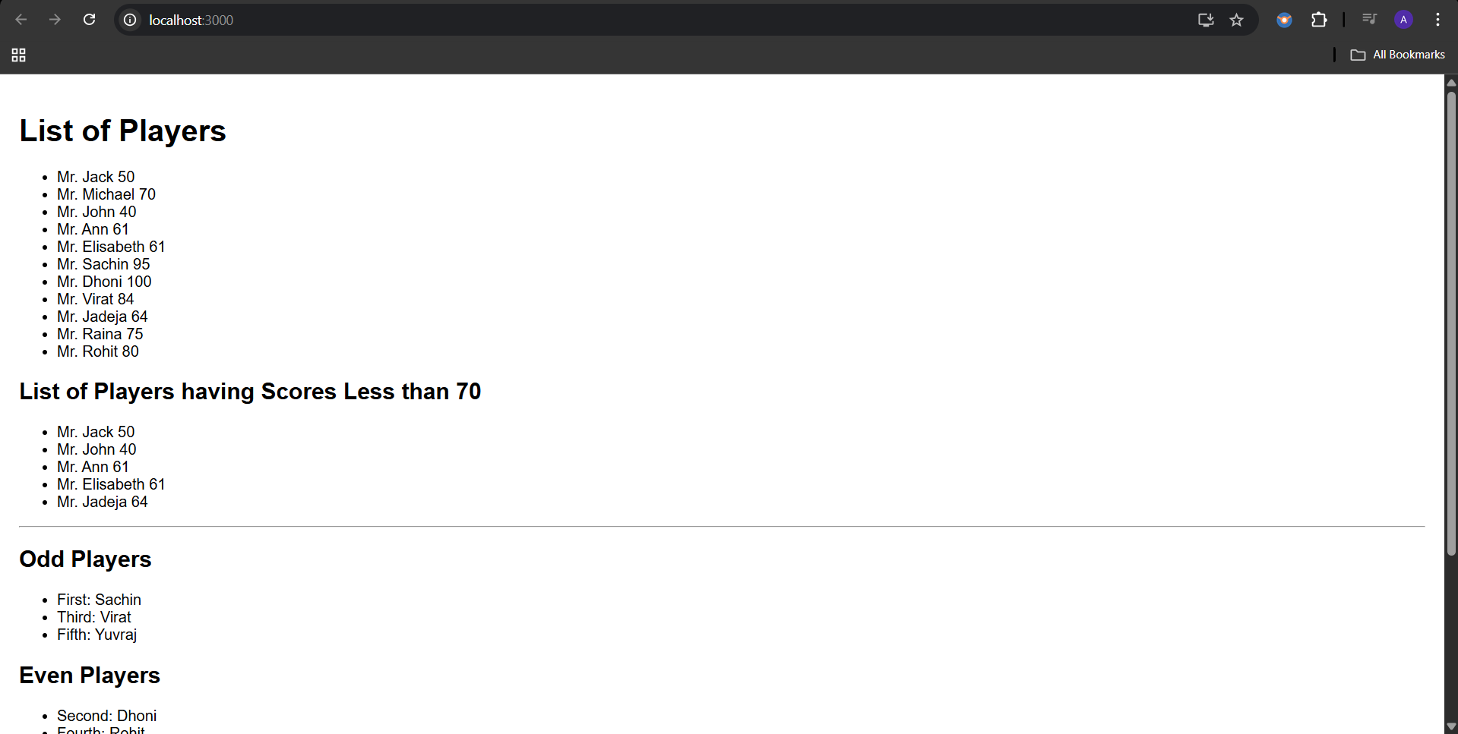

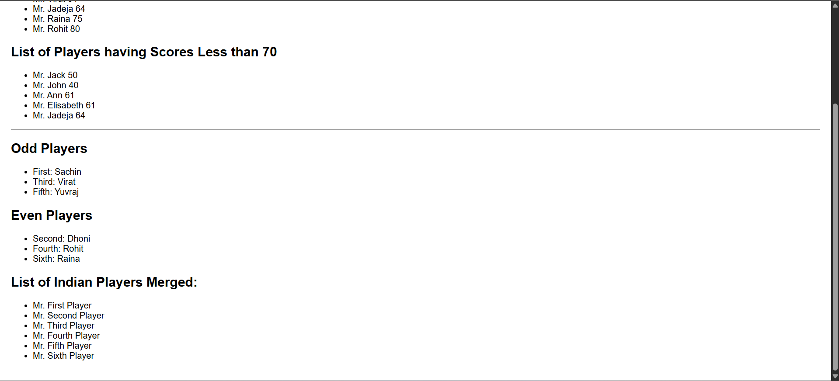

**Exercise 10: JSX**

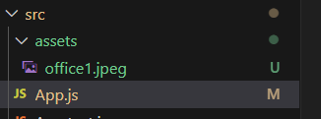

//App.js

import React from 'react';

import officeImg from './assets/office1.jpeg';

function App() {

  const office = {

    name: 'Dream Office',

    rent: 58000,

    address: '456 Green Valley, Pune',

    image: officeImg

  };

  const rentStyle = {

    color: office.rent < 60000 ? 'red' : 'green',

    fontWeight: 'bold'

  };

  return (

    <div style={{ padding: '20px', fontFamily: 'Arial' }}>

      <h1>🏢 Office Space Rental App</h1>

      <div style={{

        border: '1px solid #ccc',

        padding: '20px',

        maxWidth: '450px',

        marginTop: '20px',

        borderRadius: '8px'

      }}>

        <img

          src={office.image}

          alt="Office"

          style={{ width: '100%', height: '250px', objectFit: 'cover', borderRadius: '5px' }}

        />

        <h2>{office.name}</h2>

        <p><strong>Address:</strong> {office.address}</p>

        <p style={rentStyle}><strong>Rent:</strong> ₹{office.rent}</p>

      </div>

    </div>

  );

}

export default App;

**//**office1.jpeg



**Output:**

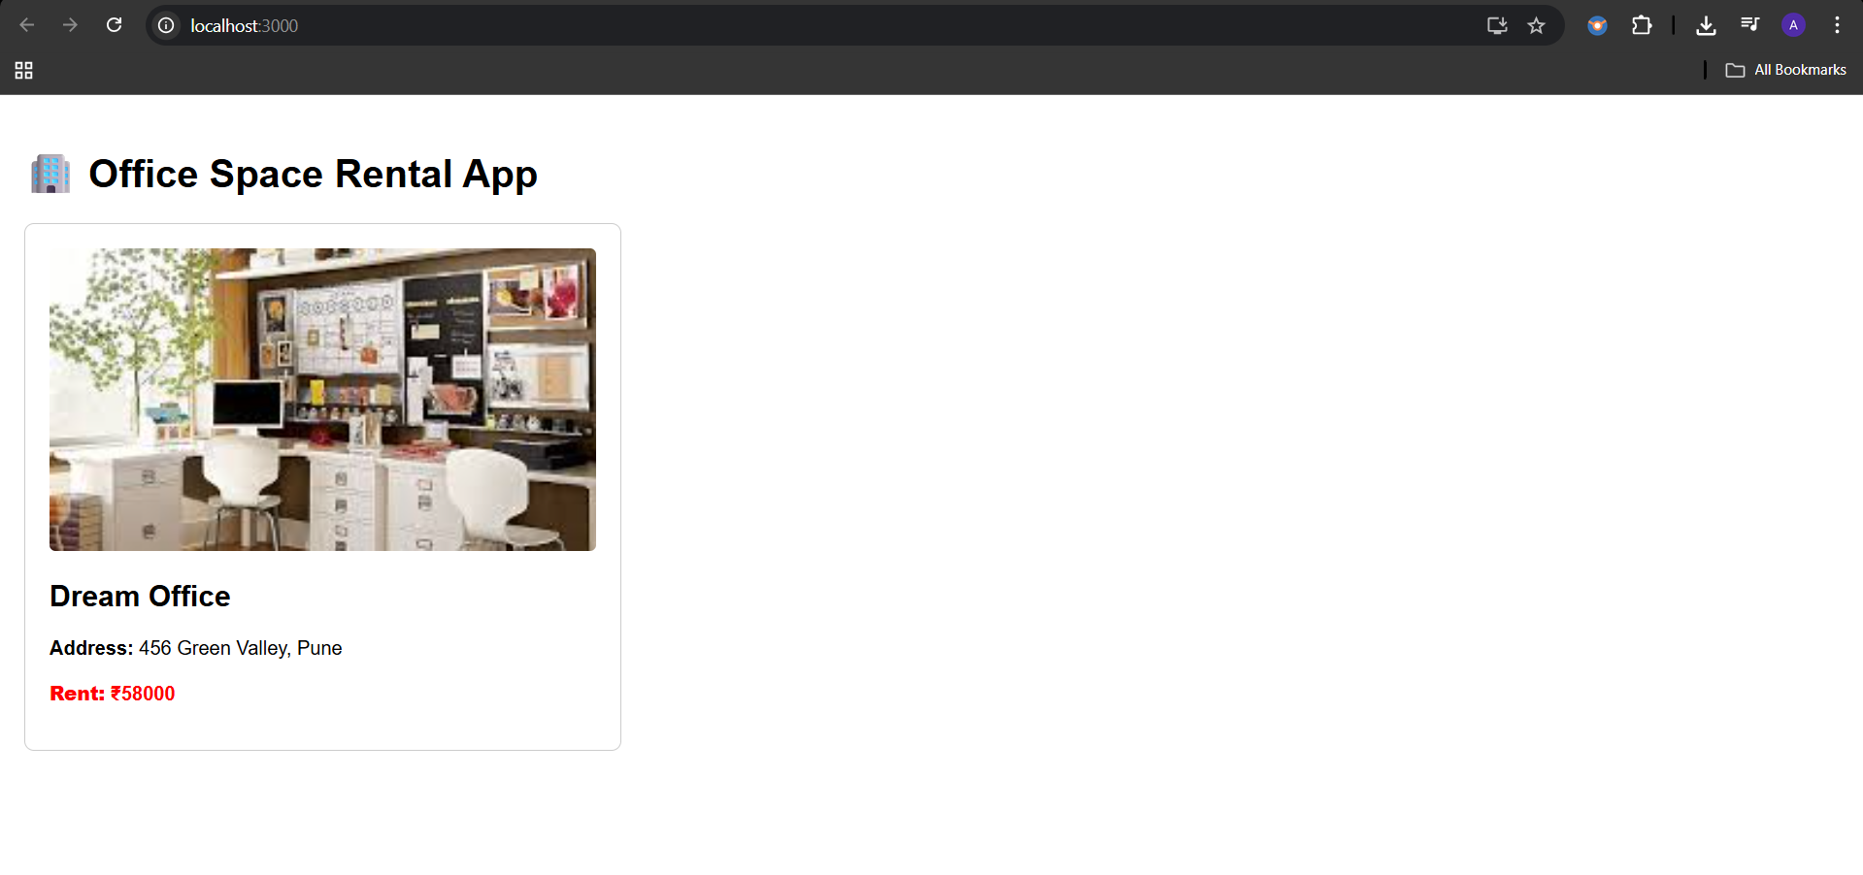

**Exercise 11: React Events**

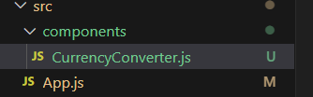

//App.js

import React, { Component } from 'react';

import CurrencyConverter from './components/CurrencyConverter';

class App extends Component {

constructor() {

super();

this.state = {

counter: 0

};

}

increment = () => {

this.setState(prevState => ({ counter: prevState.counter + 1 }));

this.sayHello();

}

sayHello = () => {

console.log('Hello! Counter was increased.');

}

decrement = () => {

this.setState(prevState => ({ counter: prevState.counter - 1 }));

}

sayWelcome = (message) => {

alert(message);

}

handleClick = (e) => {

console.log('Synthetic Event Type:', e.type);

alert('I was clicked');

}

render() {

return (

<div style={{ padding: '30px', fontFamily: 'Arial' }}>

<h1>React Event</h1>

<h2>Counter: {this.state.counter}</h2>

<button onClick={this.increment}>Increment</button>{' '}

<button onClick={this.decrement}>Decrement</button>

<br /><br />

<button onClick={() => this.sayWelcome('Welcome to React Events!')}>Say Welcome</button>

<br /><br />

<button onClick={this.handleClick}>Synthetic Event (onClick)</button>

<br /><br />

<CurrencyConverter />

</div>

);

}

}

export default App;

//CurrencyConverter.js

import React, { useState } from 'react';

function CurrencyConverter() {

  const [rupees, setRupees] = useState('');

  const [euros, setEuros] = useState('');

  const handleSubmit = () => {

    const euroValue = parseFloat(rupees) / 90; // Assuming 1 Euro = ₹90

    setEuros(euroValue.toFixed(2));

  };

  return (

    <div style={{ marginTop: '40px' }}>

      <h2> Currency Converter (INR → EURO)</h2>

      <input

        type="number"

        placeholder="Enter amount in ₹"

        value={rupees}

        onChange={(e) => setRupees(e.target.value)}

      />

      {' '}

      <button onClick={handleSubmit}>Convert</button>

      <p>Converted Amount: €{euros}</p>

    </div>

  );

}

export default CurrencyConverter;

**Output**

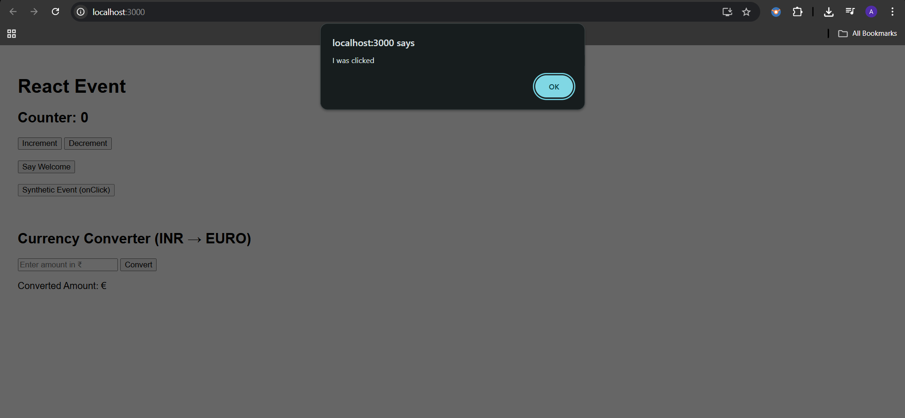

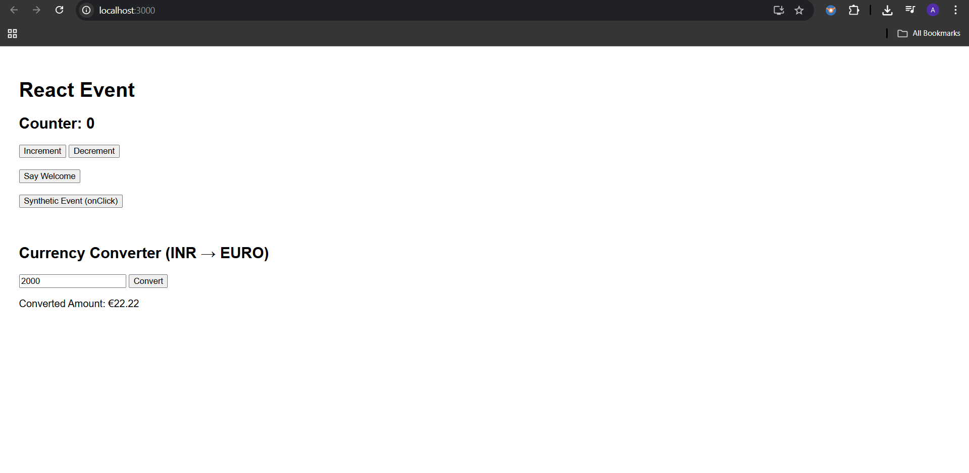

**Exercise 12: Conditional Rendering**

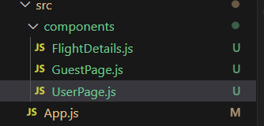

//App.js

import React, { Component } from 'react';

import GuestPage from './components/GuestPage';

import UserPage from './components/UserPage';

class App extends Component {

  constructor() {

    super();

    this.state = {

      isLoggedIn: false

    };

  }

  handleLogin = () => {

    this.setState({ isLoggedIn: true });

  }

  handleLogout = () => {

    this.setState({ isLoggedIn: false });

  }

  render() {

    let content;

    if (this.state.isLoggedIn) {

      content = <UserPage onLogout={this.handleLogout} />;

    } else {

      content = <GuestPage onLogin={this.handleLogin} />;

    }

    return (

      <div style={{ padding: '30px', fontFamily: 'Arial' }}>

        <h1>Ticket Booking App</h1>

        {content}

      </div>

    );

  }

}

export default App;

//FlightDetails.js

import React from 'react';

function FlightDetails() {

  return (

    <div>

      <h2>Available Flights</h2>

      <ul>

        <li>Flight 1: Chennai - Delhi – ₹4500</li>

        <li>Flight 2: Mumbai - Bangalore – ₹3500</li>

        <li>Flight 3: Kolkata - Hyderabad – ₹4000</li>

      </ul>

    </div>

  );

}

export default FlightDetails;

//GuestPage.js

import React from 'react';

import FlightDetails from './FlightDetails';

function GuestPage({ onLogin }) {

  return (

    <div>

      <h2>Welcome, Guest!</h2>

      <FlightDetails />

      <button onClick={onLogin}>Login to Book</button>

    </div>

  );

}

export default GuestPage;

//UserPage.js

import React from 'react';

import FlightDetails from './FlightDetails';

function UserPage({ onLogout }) {

  return (

    <div>

      <h2>Welcome, User!</h2>

      <FlightDetails />

      <button style={{ marginTop: '10px' }}>Book Ticket</button>

      <br /><br />

      <button onClick={onLogout}>Logout</button>

    </div>

  );

}

export default UserPage;

**Output:**

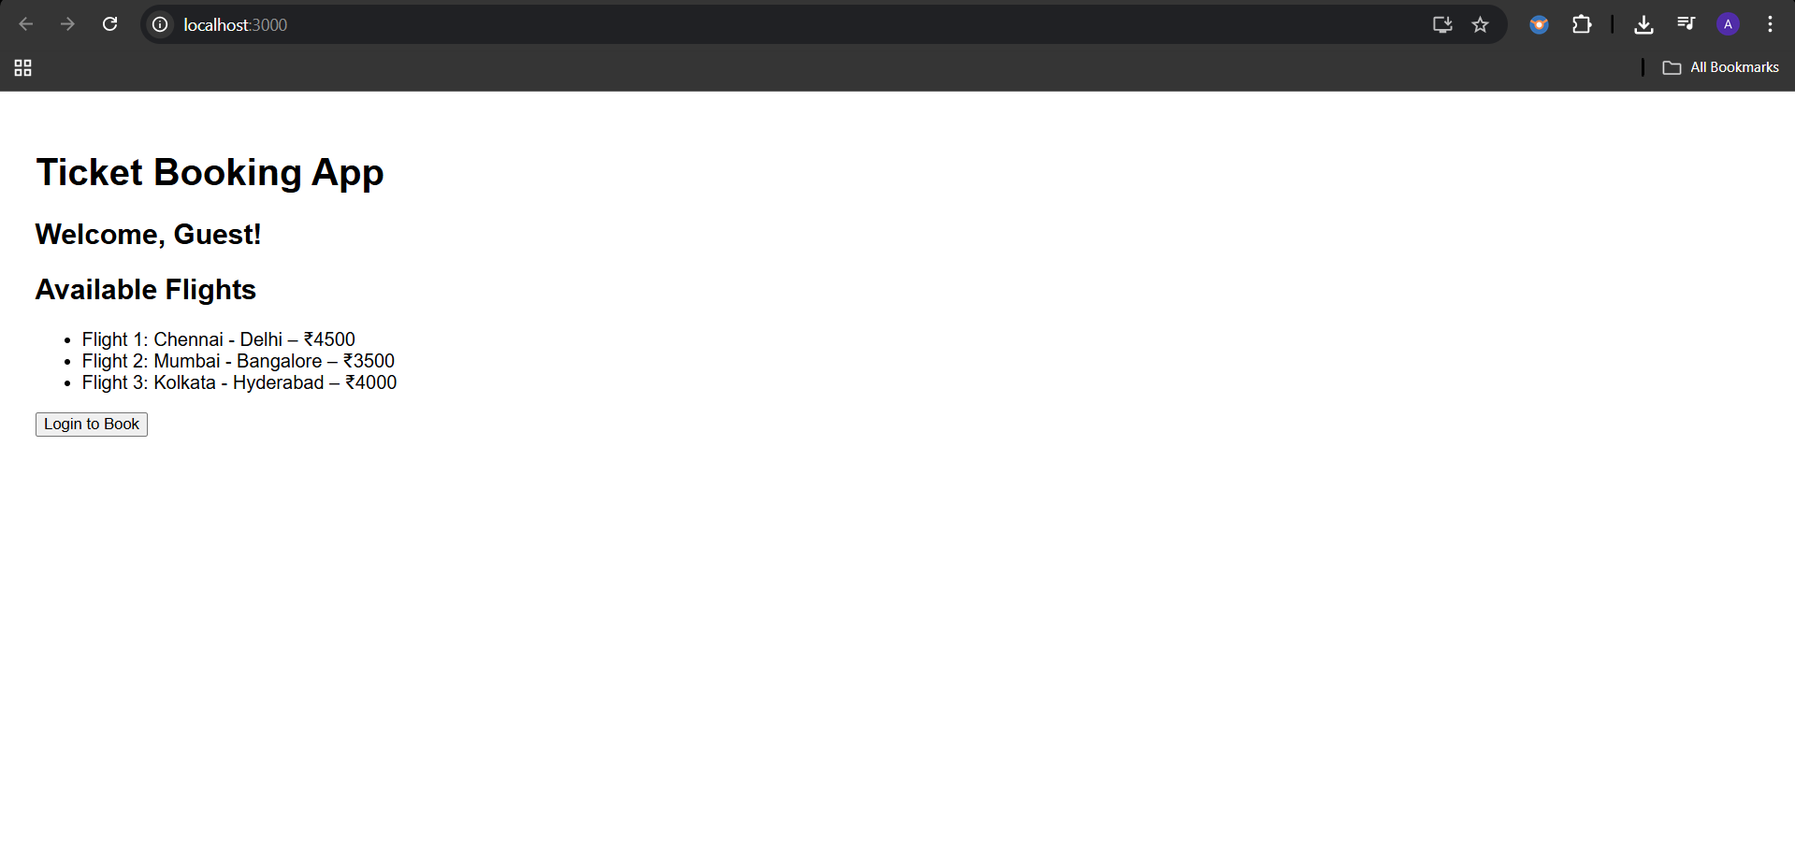

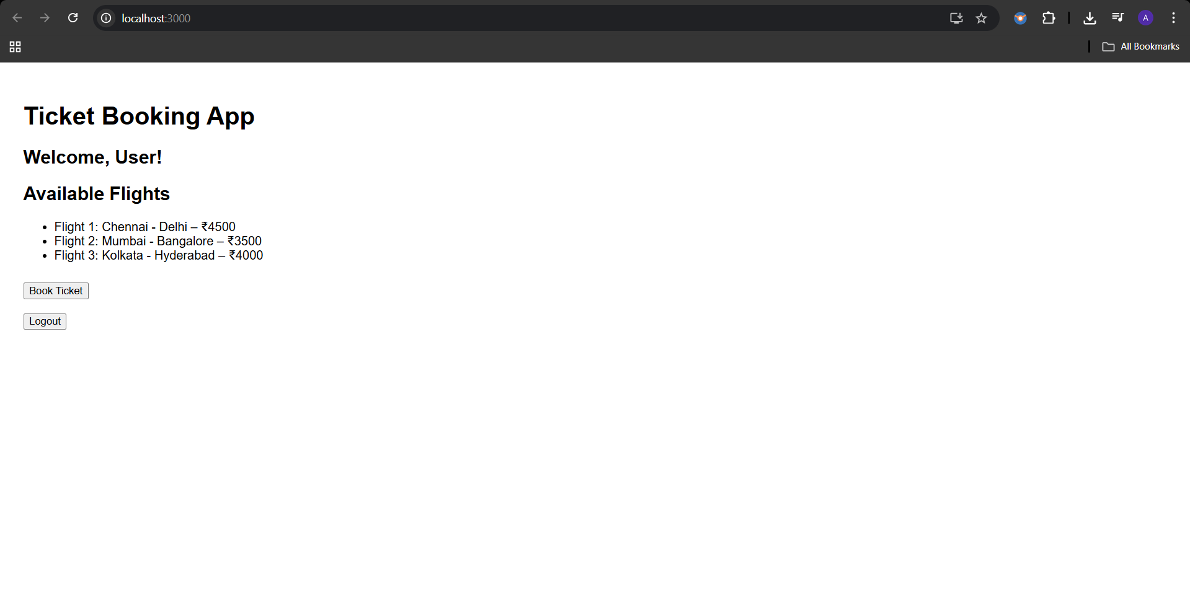

**Exercise 13: Conditional Rendering**

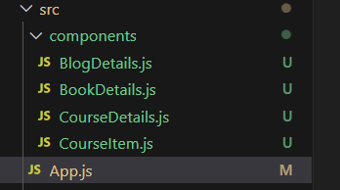

//App.js

import React, { useState } from 'react';

import BookDetails from './components/BookDetails';

import BlogDetails from './components/BlogDetails';

import CourseDetails from './components/CourseDetails';

function App() {

  const [section, setSection] = useState("book");

  const handleChange = (event) => {

    setSection(event.target.value);

  };

  let selectedComponent; // Element variable rendering

  if (section === "book") {

    selectedComponent = <BookDetails />;

  } else if (section === "blog") {

    selectedComponent = <BlogDetails />;

  } else {

    selectedComponent = <CourseDetails />;

  }

  return (

    <div style={{ padding: '20px', fontFamily: 'Arial' }}>

      <h1>Blogger App</h1>

      <label>Select Section: </label>

      <select onChange={handleChange} value={section}>

        <option value="book">Book Details</option>

        <option value="blog">Blog Details</option>

        <option value="course">Course Details</option>

      </select>

      <hr />

      {/* Element variable used */}

      {selectedComponent}

      {/* Conditional rendering using ternary */}

      <div style={{ marginTop: '20px' }}>

        {section === "course" ? (

          <p>You are viewing course details.</p>

        ) : (

          <p>Switch to Course Details to see more.</p>

        )}

      </div>

      {/* Logical AND Rendering */}

      {section === "blog" && <p>You are currently viewing blogs.</p>}

    </div>

  );

}

export default App;

//BookDetails.js

import React from 'react';

function BookDetails() {

  return (

    <div>

      <h2>Book Details</h2>

      <ul>

        <li>Title: Learning React</li>

        <li>Author: Alex Banks</li>

        <li>Pages: 350</li>

      </ul>

    </div>

  );

}

export default BookDetails;

;

//BlogDetails.js

import React from 'react';

function BlogDetails() {

  return (

    <div>

      <h2>Blog Details</h2>

      <ul>

        <li>Post: React Conditional Rendering</li>

        <li>Author: Jane Doe</li>

        <li>Date: 2025-08-01</li>

      </ul>

    </div>

  );

}

export default BlogDetails;

//CourseDetails.js

import React from 'react';

import CourseItem from './CourseItem'

function CourseDetails() {

  const courses = [

    { id: 1, name: "React Basics", duration: "5 hours" },

    { id: 2, name: "React Advanced", duration: "8 hours" },

    { id: 3, name: "React with Redux", duration: "6 hours" }

  ];

  return (

    <div>

      <h2>Course Details</h2>

      <ul>

        {courses.map(course => (

          <CourseItem key={course.id} course={course} />

        ))}

      </ul>

    </div>

  );

}

export default CourseDetails;

//CourseItem.js

import React from 'react';

function CourseItem({ course }) {

  return (

    <li>

      <strong>{course.name}</strong> – {course.duration}

    </li>

  );

}

export default CourseItem;

**Output:**

